

Department of Computer Science and Information Technology

Diploma in Information Technology/Web Development

TWEB 224 Web programming

September Semester, 2019

Group Assignment

Title: Chino Train Ticket Booking System

|  |  |  |  |
| --- | --- | --- | --- |
| Student Name 1: | Lim Yong Jing | Student ID: | 1820039-DWD |
| Student Name 2: | Ng Si Liang | Student ID: | 1820053-DIT |
| Student Name 3: | Koo Yin Zhen | Student ID: | 1850345-DWD |
| Student Name 4: | Yap Woon Hong | Student ID: | 1850441-DIT |
| Student Name 5: | Lau Cia Chang | Student ID: | 1850118-DIT |

**Table of content**

1. INTRODUCTION 3

2. Function of module 4

3. Screenshots of website 5

3.1. User and Admin side 5

3.2. User side 8

3.3. Admin side 11

**Introduction**

We are creating a web page using php coding to create a train booking. This is our final group project. The purpose of this project is to let every people can make a booking ticket easily. Why it was easy, is because nowadays everyone has a smart Phone or computer and using internet in everywhere in this generation. No exception, we creating this web page is also to convince everyone in real life. It not complicated at all; user just open our booking train web page that we create user just need to make a simple information inside. The advantage is everyone does not need to go to the train station to line up in the counter for wasting time. If there is any problem that user faces, they can contact customer service in our web page. Customer service can help user to solve any problem they did not understand.

**The function of module**

**Homepage**

* Homepage module is used for displaying lastest updated information
* We have 3 home page such as guest, member, admin.

**Login**

* Login module is used for the user or admin access the system
* Member login and admin login
* Register button

**Booking**

* Booking module allow user to book the ticket
* You need to insert the name, date, time, origin, and the number of ticket.
* Admin can look at the databases.

**Contact us**

* Allow user to give opinion or ask any question they faced.
* User is required to fill up user email, name, subject and description.4

**Screenshot**

**User & Admin**

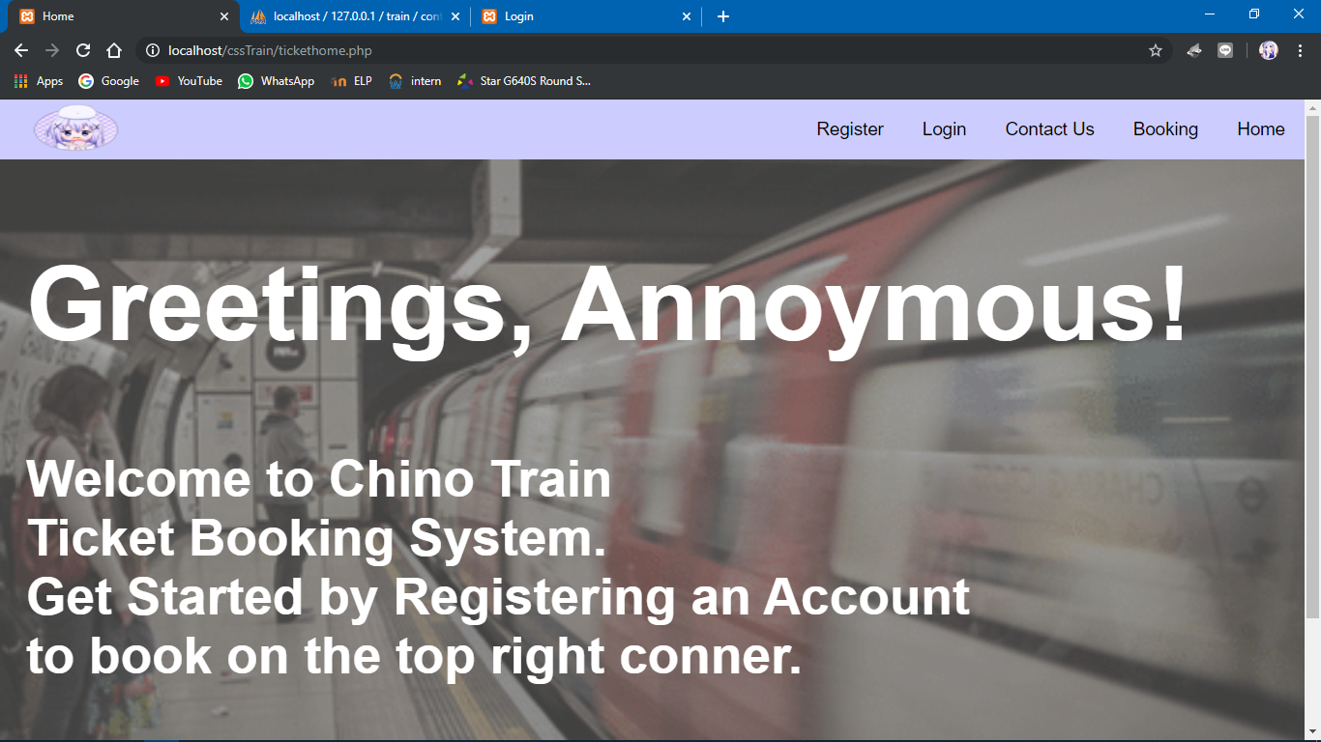

**Login page**

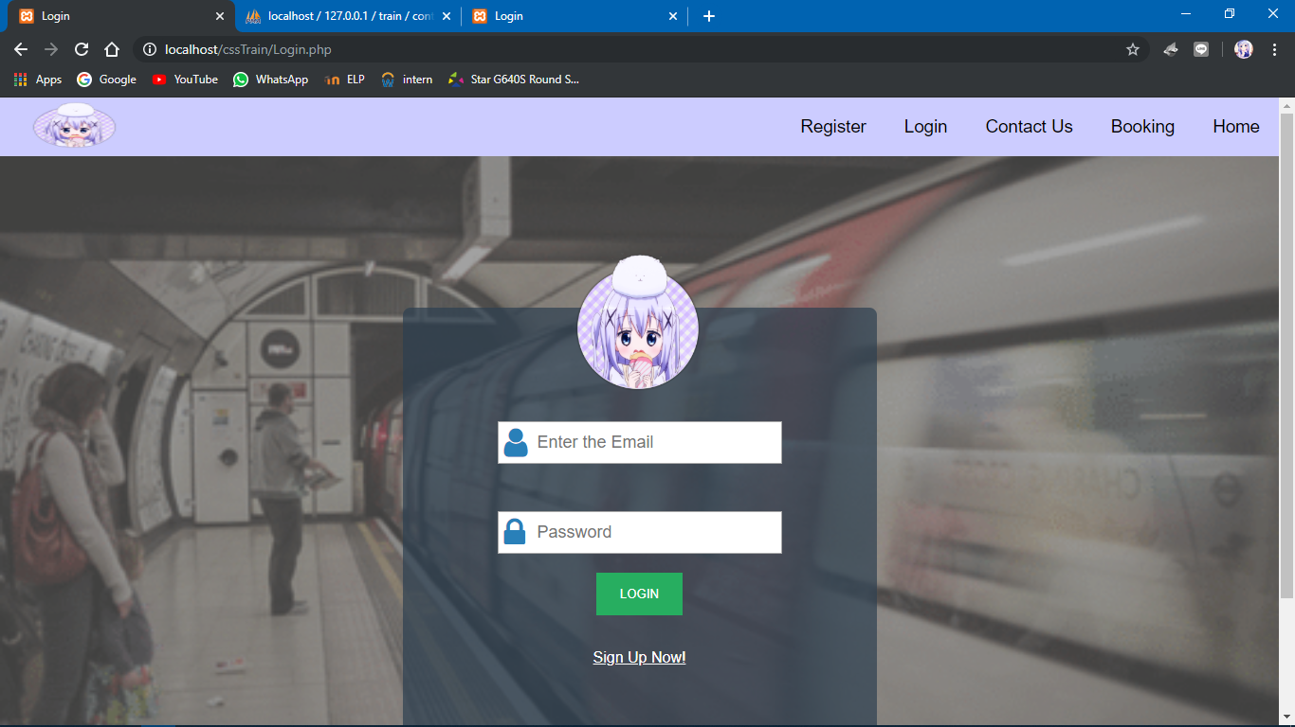

**Register page**

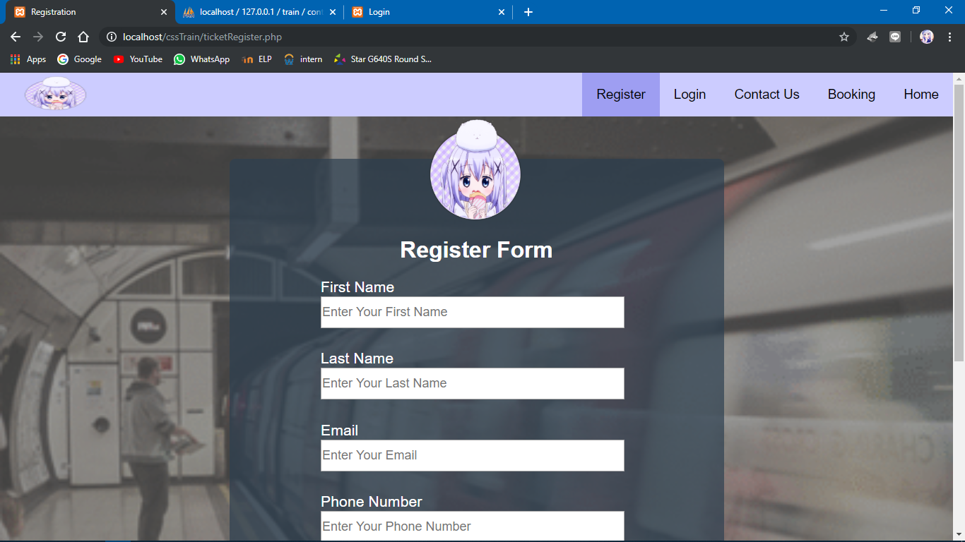

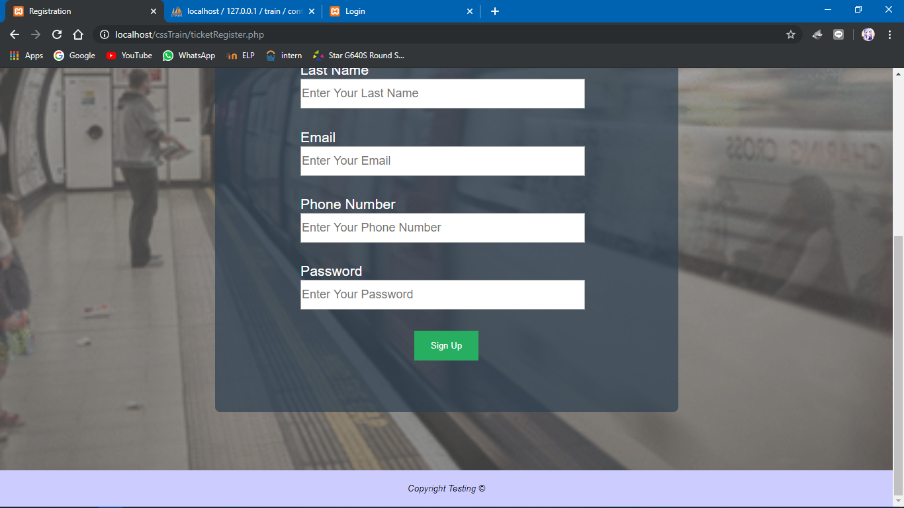

**Contact us page**

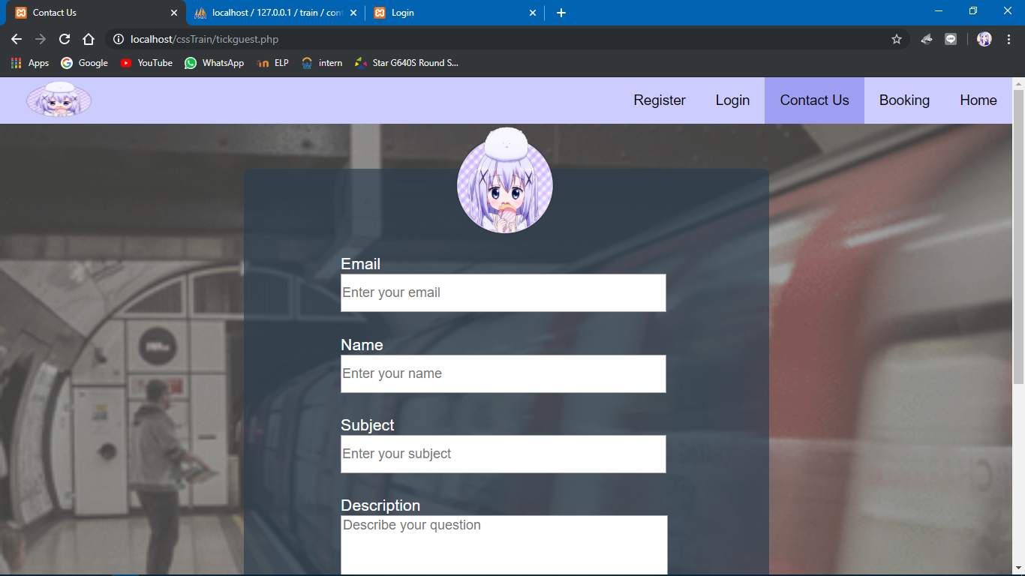

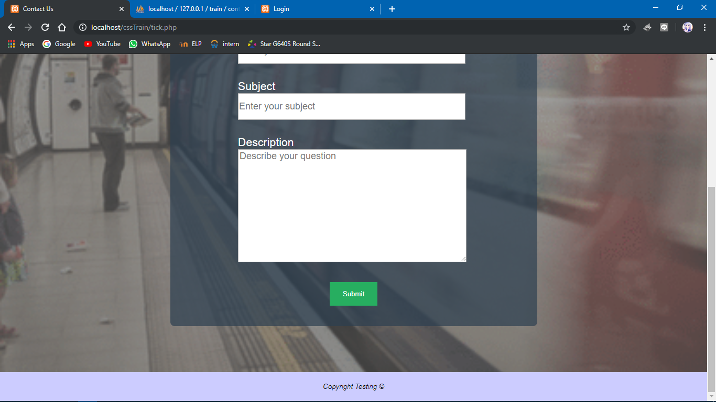

**User side**

**Home page**

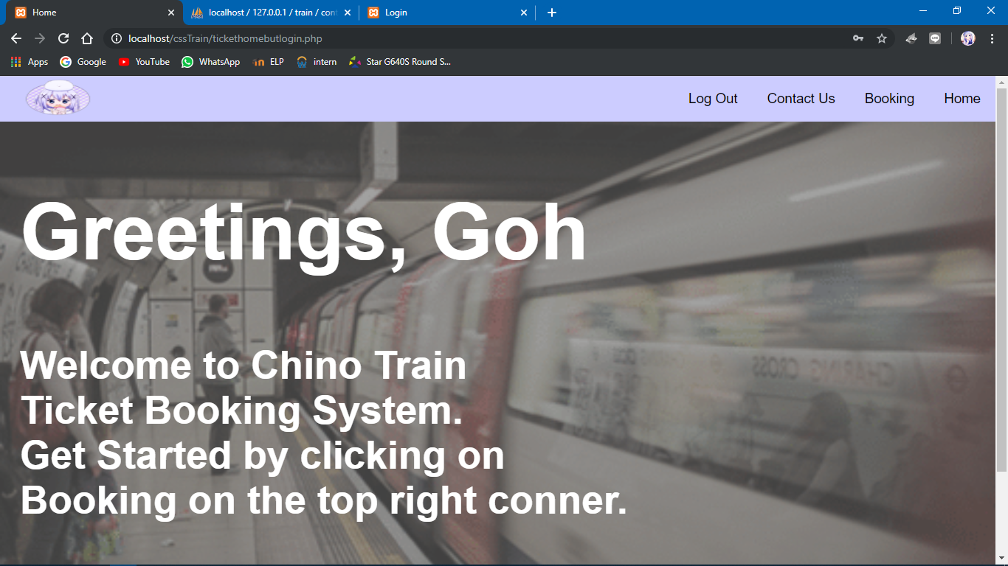

**User booking page**

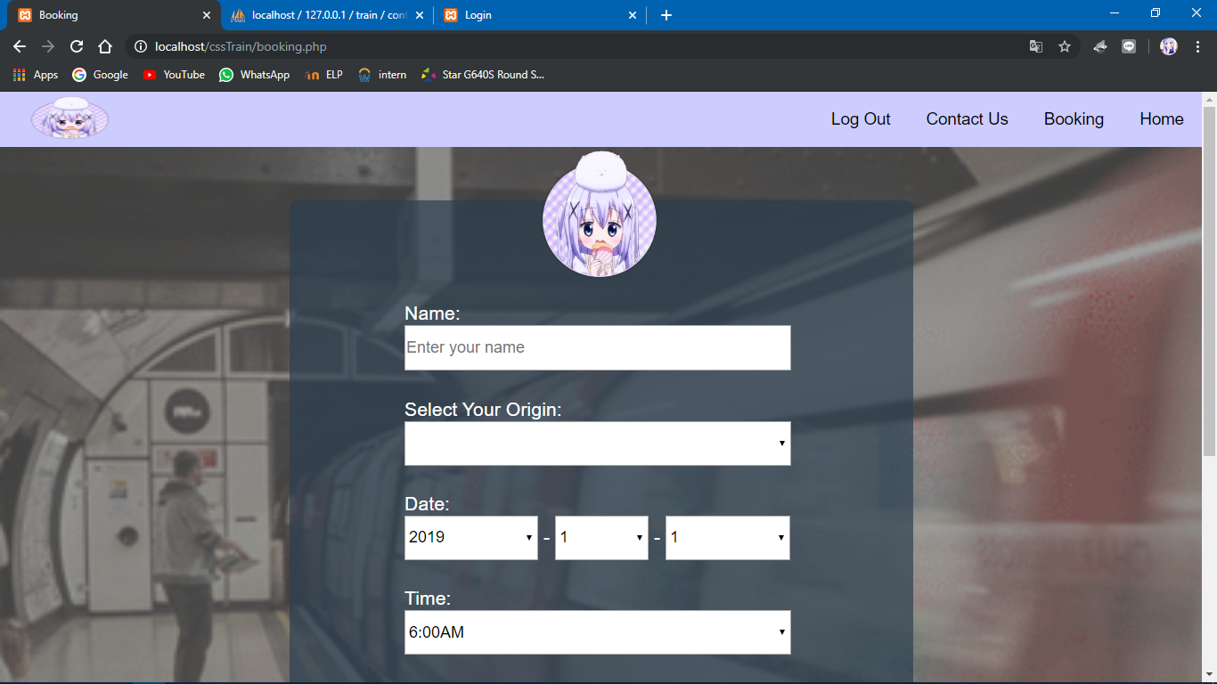

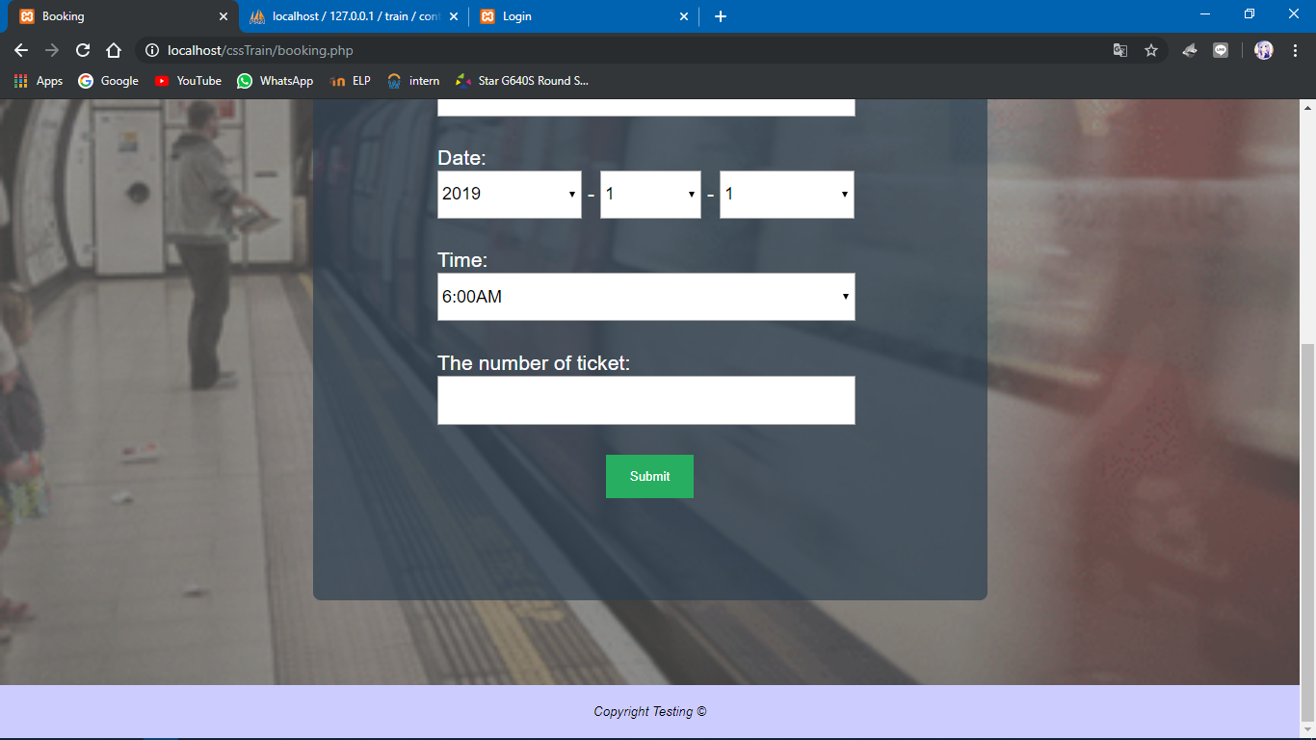

**User Contact Us Page**

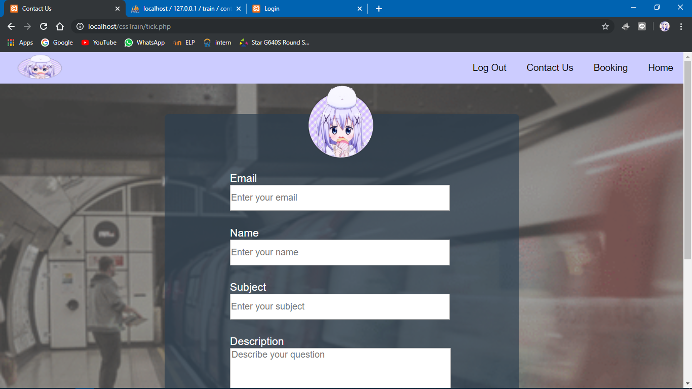



**Admin side**

**Admin login page**

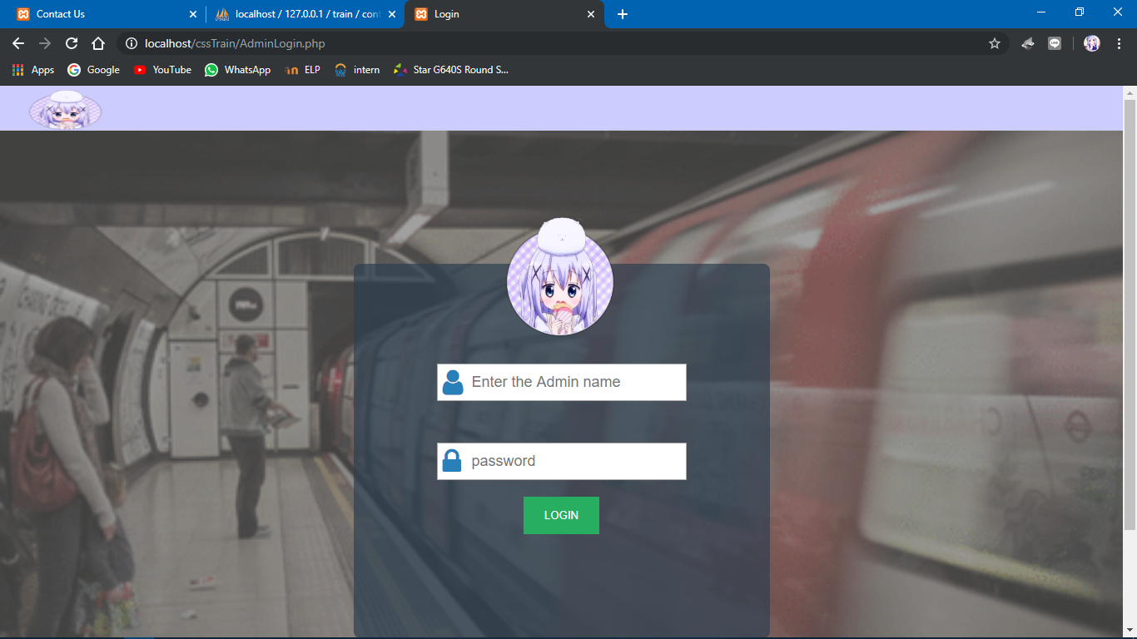

**Admin home page**

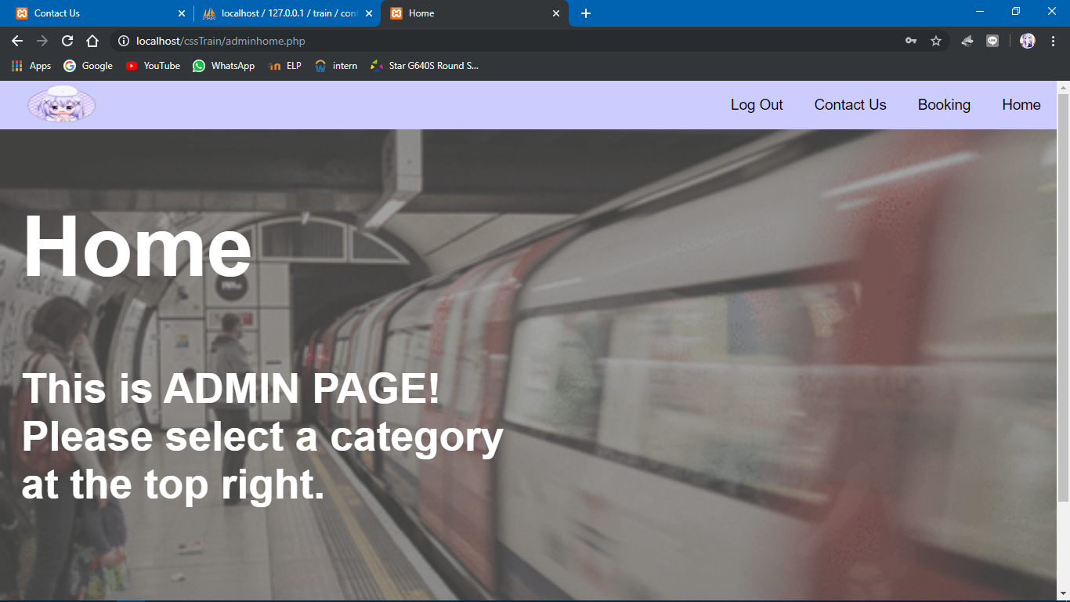

**User booked train information**

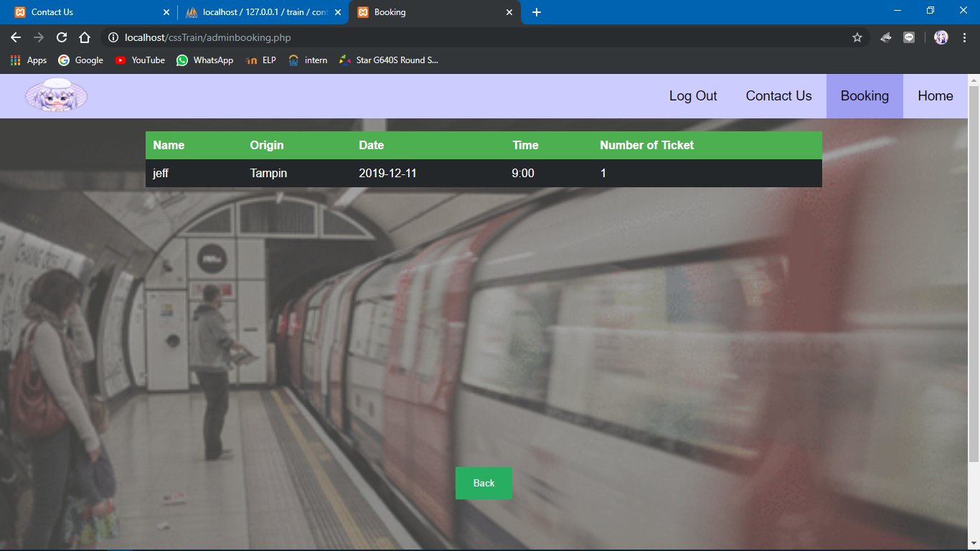

**User contact us information**

